AA Portable Power Corp.

SPECIFICATION FOR

MODEL NO. : H00450018-US-1
1.8 WATTS CHARGER

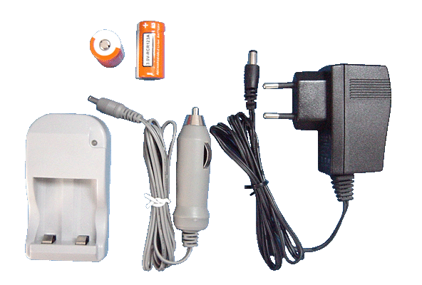

Address：2700 Rydin Rd. Unit C Richmond CA 94804
TEL：1-800-448-4428, 510-525-4710
FAX： 510-525-4718

DESCRIPTION |  | SPECIFICATION |  | HCT
MODEL NO. |  | H00450018-US-1 |  | DOCUMENT NO.
PREPARED BY | DESIGNED BY |  | CHECKED BY | APPROVED BY | ISSUED DATE | 12-02-2005
HEQINGQIANG |  |  |  |  | REV. | A

Revision History

Rev | Description | Date
A0 | Original | 2005.12.2

1.0 INPUT 4
1.1 Voltage 4
1.2 Frequency 4
1.3 Current .4
1.4 Power efficiency 4
2.0 OUTPUT 4
2.1 charge curve 4
2.2 Led display 4
3.0 PROTECTION 4
3.1 Short circuit protection 4
4.0 ENVIRONMENT: 4
4.1 Ambient operation temperature 4
4.2 Ambient operation relative humidity 4
4.3 Ambient storage temperature 4
4.4 Ambient storage relative humidity 4
5.0 MTBF 5
6.0 DIMENSION.………………………………………………………………5

1.0 INPUT

1.1 Voltage

Minimum | Normal | Maximum | Unit
100 | 115/230 | 240 | Vrms

1.2 Frequency
47Hz~63Hz

1.3 Current
0.4A.(MAX)

1.4 Power efficiency
80% (min.) at full load, 115Vac 60Hz.

2.0 OUTPUT

2.1 Charge curve
Charger current(A)

0.4A

4.5V

Voltage(V)
2.1.1 This charger can charge RCR123 Li-ion battery
2.1.2 End charge by 1/10C detection

2.2 Led display

Red on charging
Green on full charge

3.0 PROTECTION

3.1 Short circuit protection
The output short to ground, it will auto-recovery without damage.

4.0 ENVIRONMENT:

4.1 Ambient operation temperature
0℃ to +40℃

4.2 Ambient operation relative humidity
20% to 85%

4.3 Ambient storage temperature
-40℃ to +70℃

4.4 Ambient storage relative humidity
10% to 95%

5.0 MTBF
40,000 hours base on bellcore TR332 document required at 25℃.

6.0 Dimension
Outline dimension:84.0L X 46.0W X 28.5(H) mm MAX;

